72

Youth Preference Survey
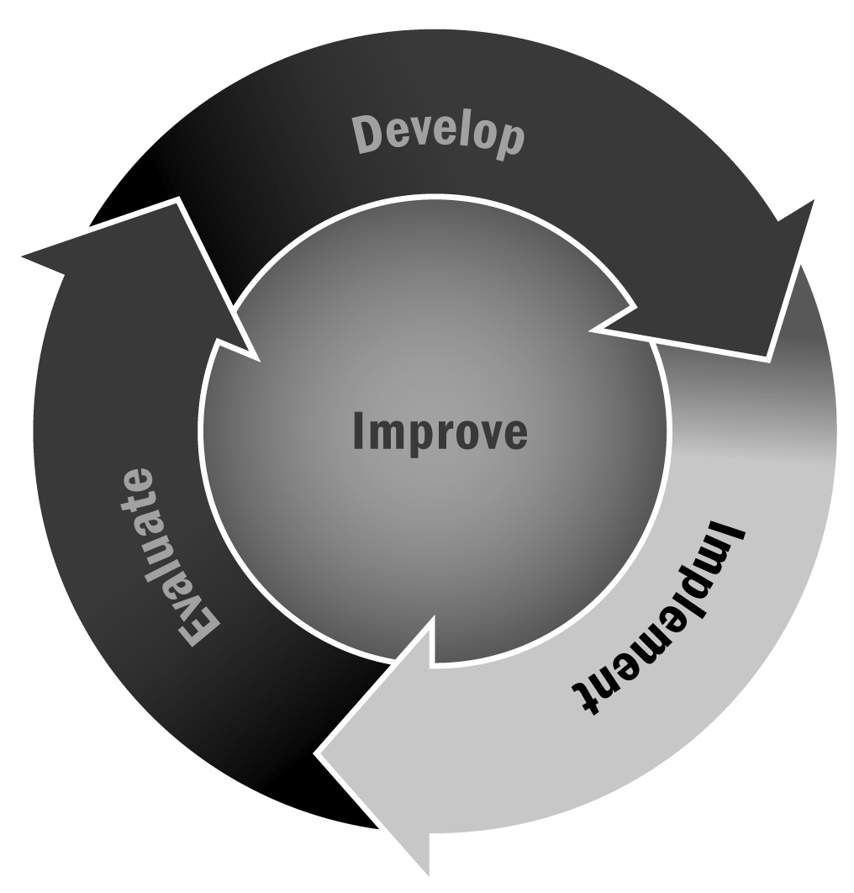
In Chapter 4, you learned that using youth surveys can help you intentionally develop activities and programming. This sample youth survey can support intentional decision-making when designing your program by identifying what youth are looking for, what they would enjoy, and how you can connect this information to your programming.
Directions: You may use or adapt this survey to determine young people’s programming preferences for your program. Feel free to add or edit questions or response options as necessary for your program. Make multiple copies of the survey; ask teachers to distribute and collect it during homeroom period or at another convenient time, and have program staff members distribute it during the opening activities.

Survey of Youth Program Preferences
We need your help! We want to create an afterschool and expanded learning program that is exciting and useful for you. Please answer the following questions about your opinions and ideas for program activities. If you would like to get even more involved in planning afterschool activities or being a club officer, ask your teacher for more information about our program.
- Please check the sentence that best describes your feelings about attending an afterschool and expanded learning program at our school. (Check one.)
- I already participate in afterschool and expanded learning activities at our school.
What activities do you participate in?
- I would be interested in going to an afterschool and expanded learning program at our school, but I don’t go right now.
- I have other responsibilities after school and could not go to an afterschool and expanded learning program at our school.
- I would not be interested in going to an afterschool and expanded learning program at our school.

- What kinds of activities would you like to do after school? (Rank your top five choices from 1 to 5, with 1 as your top choice.) Feel free to add your own ideas.
 | Academic content areas
❒ | English language arts |  | ❒ | Science/science, technology, engineering, math (STEM)
❒ | Math |  | ❒ | History/social studies
 | Homework help |  |  | Social and emotional well-being
 | Tutoring |  |  | Sports
 | Computer/technology skills |  |  | Physical fitness
 | Creative arts |  |  | Service learning
 | Healthy living |  |  | Cultural appreciation and diversity
 | Other, please specify:
- What are some ways you would like to get involved in the afterschool and expanded learning program? (Check all that apply.)
- Deciding what programs to offer
- Advertising the program
- Planning afterschool activities
- Being a club officer
- Your idea:
- I am not interested in getting involved.
If you checked “not interested,” please explain why:

- Which types of “advertisements” would convince you and your friends to participate in afterschool and expanded learning activities? (Check all that apply.)
- Student-designed posters around your school
- Flyers mailed home
- Social media updates (Facebook, Twitter)
- Presentations by youth who are in the program
- Articles about the program in the school newspaper
- Daily announcements about the program (read by an adult)
- Daily announcements about the program (read by a young person)
- Rewards—such as homework passes, gift certificates, or other treats—for youth who regularly attend activities
- Your idea:
- Your idea:

Your Name (please print):
Your Homeroom Teacher or Room Number (if applicable):

Thank you.

